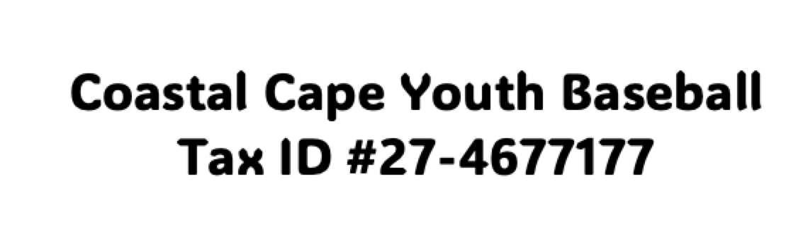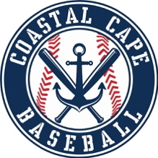
Dear Community Businesses,
The tradition of local business sponsorship has been a cornerstone of Little League Baseball since its inception in 1939. As part of the Cal Ripken division of Babe Ruth Baseball, Coastal Cape Youth Baseball is proud to continue this legacy by offering competitive baseball opportunities for boys and girls ages 7-16 in the Lower Cape and Outer Cape regions.
As we prepare for our 2025 season, we remain committed to providing a positive and enriching experience for our players. However, our registration fees do not fully cover the operational expenses necessary to run the program. These costs include insurance, field maintenance, game officials, equipment, uniforms, baseballs, and providing hardship fee waivers for families in need. As a non-profit organization, run entirely by volunteer administrators and coaches, we rely on the generosity of businesses like yours to help make each season a success.
We would be honored if you would consider supporting Coastal Cape Youth Baseball through one of our sponsorship opportunities. Your contribution would not only help sustain our league, but also provide valuable visibility for your business within our community. If you have another idea for a donation or partnership, we would love to hear from you. From sponsoring individual players to participating in raffles throughout the season, we have a variety of ways for you to get involved.
Please reach out to us at info@coastalcapebaseball.com for more information on sponsorship options or to discuss other ways you can contribute.
Thank you for your consideration and support. Together, we can continue to make youth baseball a cherished tradition in our community.
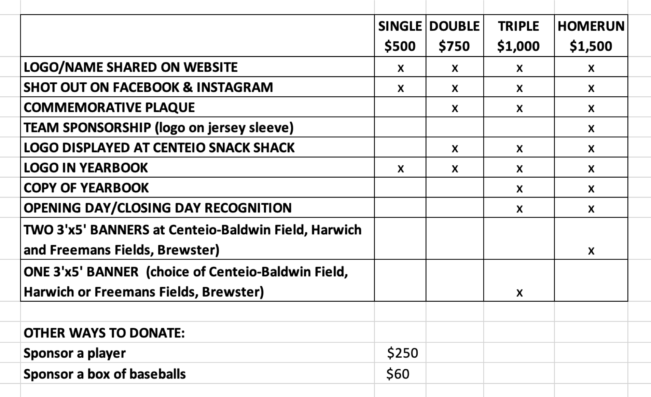

Payments:
Venmo - @coastalcapebaseball
Online – https://go.teamsnap.com/forms/413550
Check – Please make checks payable to Coastal Cape Youth Baseball and mail to: Coastal Cape Youth Baseball, Attn: Ken Taber, PO Box 854 N. Eastham, MA 02651 along with a copy of this agreement.

Artwork: Please submit artwork online. Banner logo files should be high resolution TIFF, EPS or PDF format. Color graphics should be saved as CMYK. Line Art should be at least 1200 dpi. We cannot accept web images. If low resolution artwork is supplied, CCYB will not be responsible for output quality of final banner artwork.

Questions: Please contact us at info@coastalcapebaseball.com

On behalf of the Coastal Cape Youth Baseball, the parents, and players – THANK YOU!!

NAME/BUSINESS: __________________________________________________________________________
PHONE: _________________________________ EMAIL: __________________________________________
DONATION SELECTION: ____________________________________________________________________

