**Dear Community Businesses:**

The practice of local business sponsorship has been a tradition utilized since the inception of Little League Baseball in 1939. Monomoy Little League and Nauset Little League joined together in 2022 to create Coastal Cape Youth Baseball, a Cal Ripken division of Babe Ruth Baseball. We are preparing for our 2024 season continuing our commitment to providing the Lower Cape and Outer Cape regions with competitive baseball opportunities for boys and girls ages 7-12.

Our registration fees do not cover all the operating expenses of program insurance, field maintenance, game officials, gear and uniforms, and granting hardship fee waivers for families in need. We are a non-profit organization run entirely by volunteer administrators and coaches and rely on the community support of sponsorship to assure each season’s success!

We would ask that you consider one of our sponsorship opportunities that would benefit the League and your business. If you have another idea of donating, we’d love to hear it! We have a lot of different opportunities from sponsoring a player to raffles throughout the season. Send us an email at [info@coastalcapebaseball.com](mailto:info@coastalcapebaseball.com)

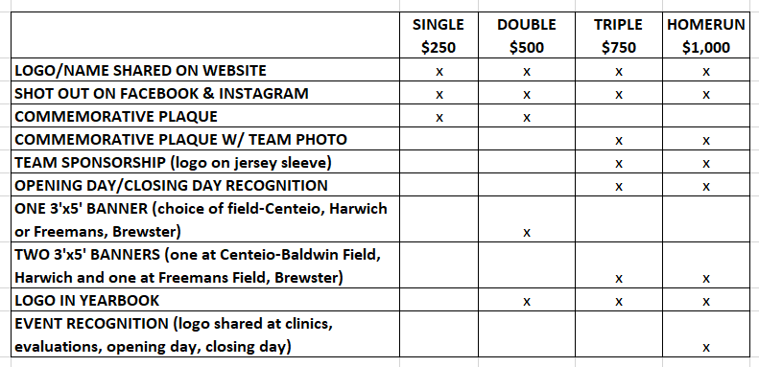

**Payments:**

**Venmo** - @coastalcapebaseball  
**Online** – <https://go.teamsnap.com/forms/413550>  
**Check** – Please make checks payable to Coastal Cape Youth Baseball and mail to: Coastal Cape Youth Baseball, Attn: Ken Taber, PO Box 854 N. Eastham, MA 02651 along with a copy of this agreement.

**Artwork**: Please submit artwork online. Banner logo files should be high resolution TIFF, EPS or PDF format. Color graphics should be saved as CMYK. Line Art should be at least 1200 dpi. We cannot accept web images. If low resolution artwork is supplied, CCYB will not be responsible for output quality of final banner artwork.

**Questions**: Please contact us at [info@coastalcapebaseball.com](mailto:info@coastalcapebaseball.com)

*On behalf of the Coastal Cape Youth Baseball, the parents, and players –* ***THANK YOU!!***

NAME/BUSINESS: __________________________________________________________________________  
PHONE: _________________________________ EMAIL: __________________________________________  
DONATION SELECTION: ____________________________________________________________________